STEP:1 CREATE MAVEN QUICK START

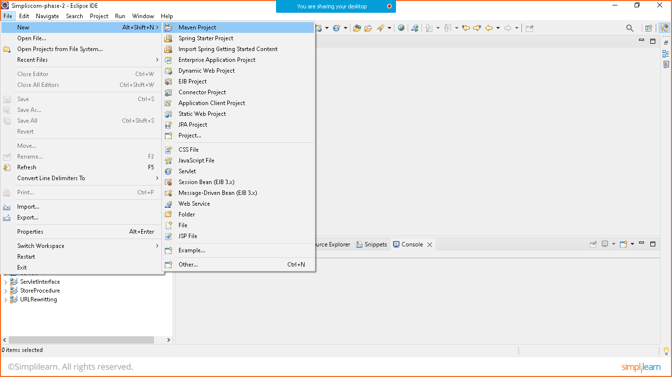

Click on next

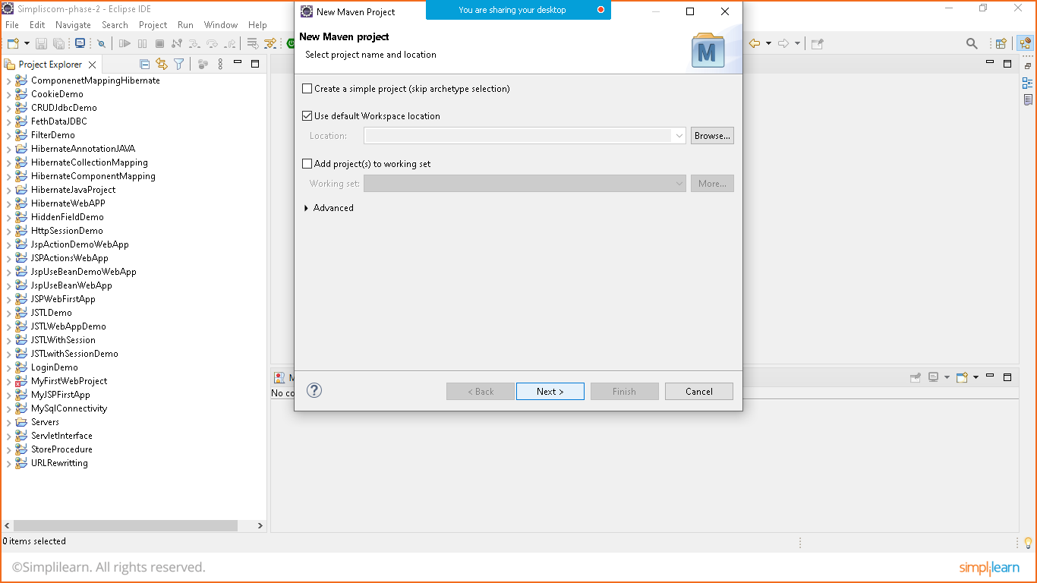

Choose QUICK STRAT

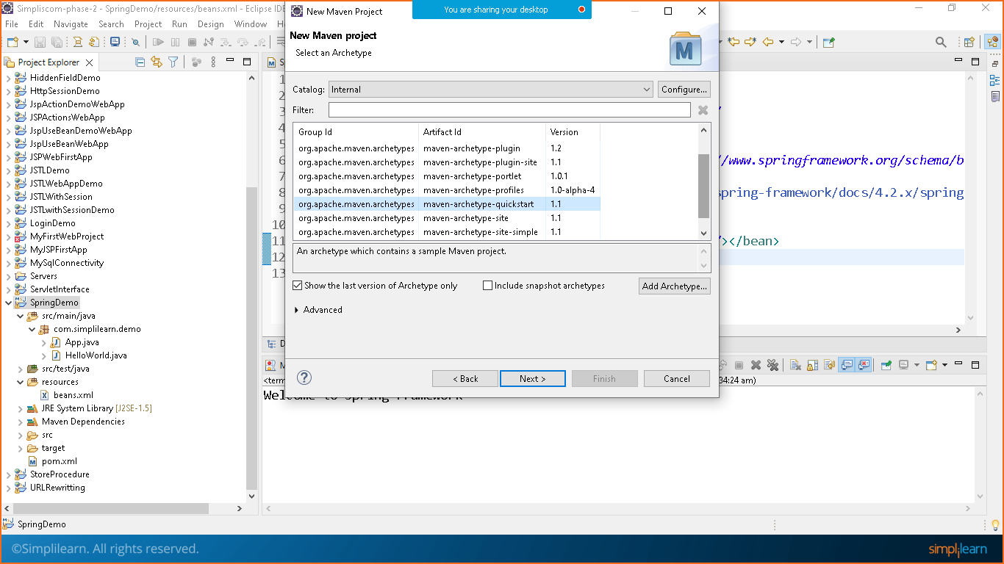

Group id and package id is same

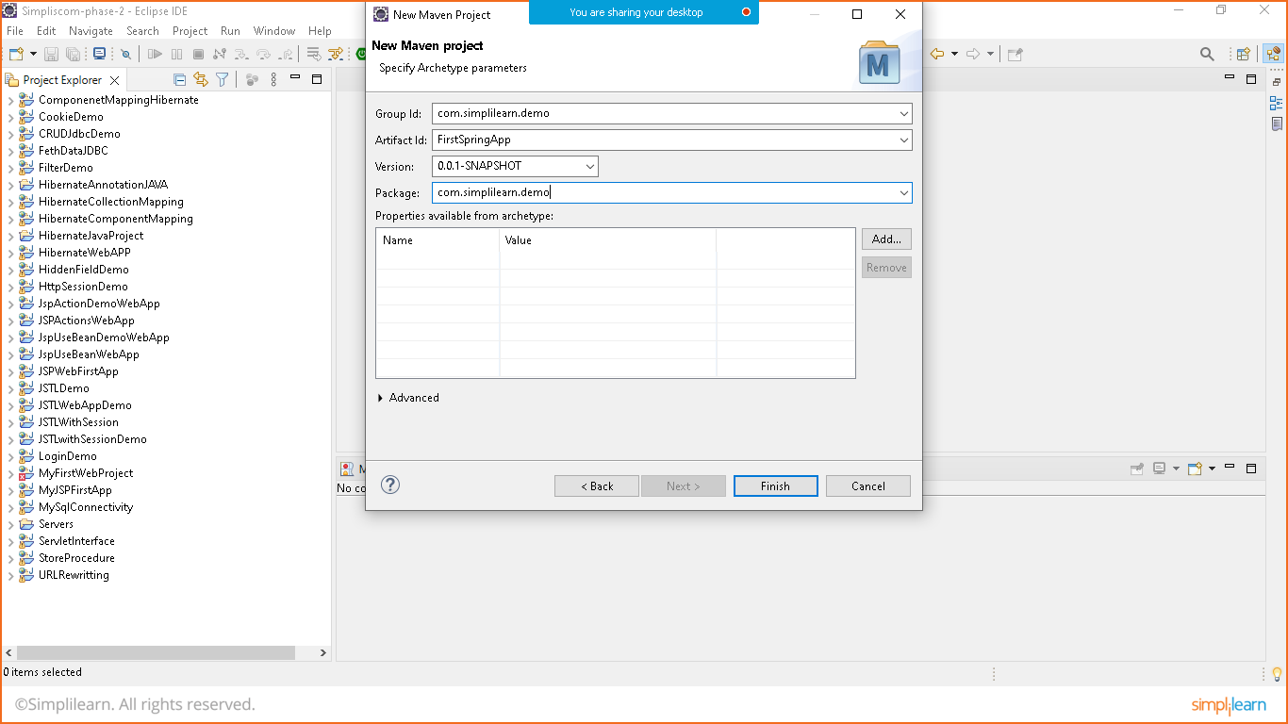

Click on finish

Step: 2 ADD DEPENDENCY

Goto> maven repository and search for below mentioned repositories

Link: https://mvnrepository.com/

POM.XML FILE

<project xmlns="http://maven.apache.org/POM/4.0.0" xmlns:xsi="http://www.w3.org/2001/XMLSchema-instance" xsi:schemaLocation="http://maven.apache.org/POM/4.0.0 http://maven.apache.org/xsd/maven-4.0.0.xsd">

<modelVersion>4.0.0</modelVersion>

<groupId>com.simplilearn.demo</groupId>

<artifactId>SpringDemo</artifactId>

<version>0.0.1-SNAPSHOT</version>

<packaging>jar</packaging>

<name>SpringDemo</name>

<url>http://maven.apache.org</url>

<properties>

<project.build.sourceEncoding>UTF-8</project.build.sourceEncoding>

<spring.version>5.3.22</spring.version>

</properties>

<dependencies>

<dependency>

<groupId>junit</groupId>

<artifactId>junit</artifactId>

<version>3.8.1</version>

<scope>test</scope>

</dependency>

<!--spring -context-->

<dependency>

<groupId>org.springframework</groupId>

<artifactId>spring-context</artifactId>

<version>${spring.version}</version>

</dependency>

<!--spring core-->

<dependency>

<groupId>org.springframework</groupId>

<artifactId>spring-core</artifactId>

<version>${spring.version}</version>

</dependency>

<!--spring beans-->

<dependency>

<groupId>org.springframework</groupId>

<artifactId>spring-beans</artifactId>

<version>${spring.version}</version>

</dependency>

</dependencies>

</project>

**Now update maven project**

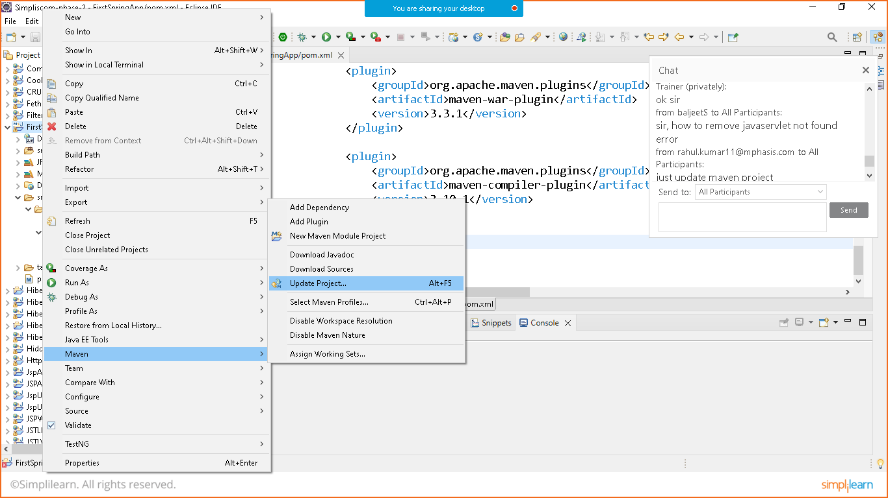

STEP:3 CREATE JAVA CLASS

Prepare HelloWorld java Class

Helloworld.java

**package** com.simplilearn.demo;

**public** **class** HelloWorld {

**public** **void** print() {

System.***out***.println("Welcome to Spring Framework");

}

}

Create resource folder

Right click on project> resource folder> prepare beans.xml file

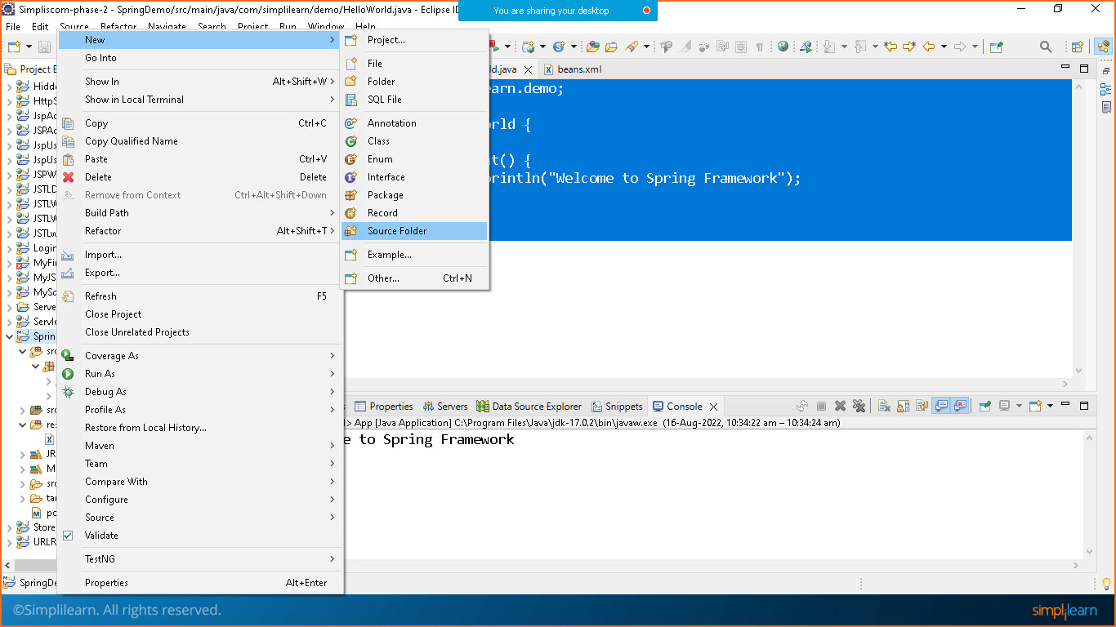

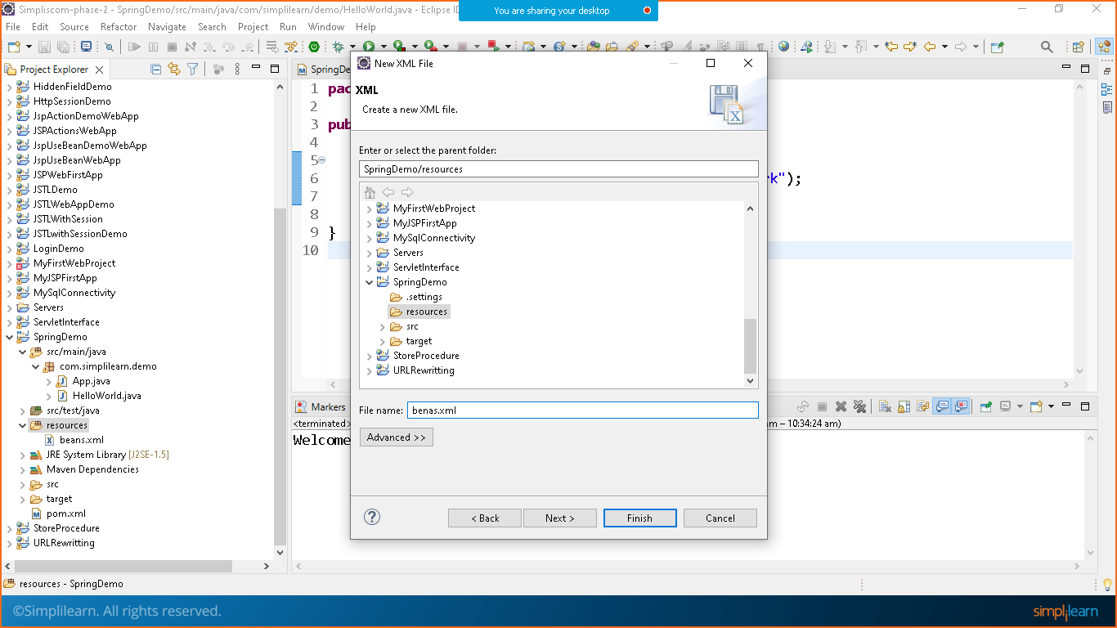

Goto google search for spring beans xsd file:

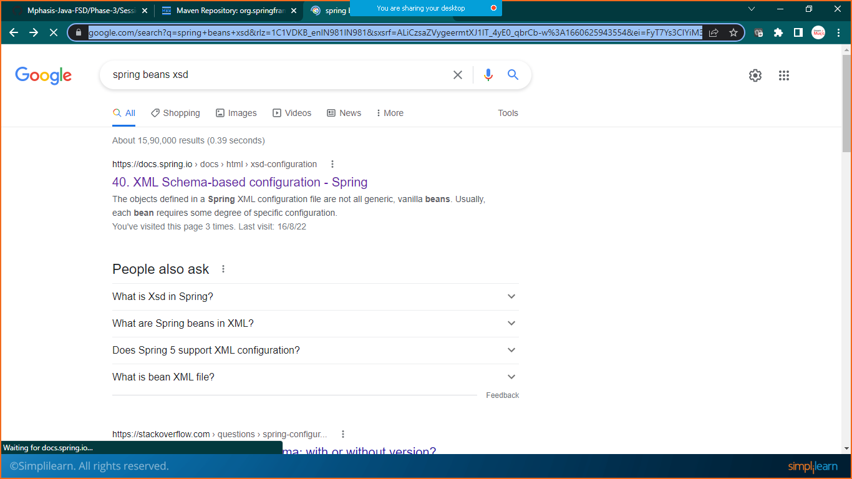

Choose the first link

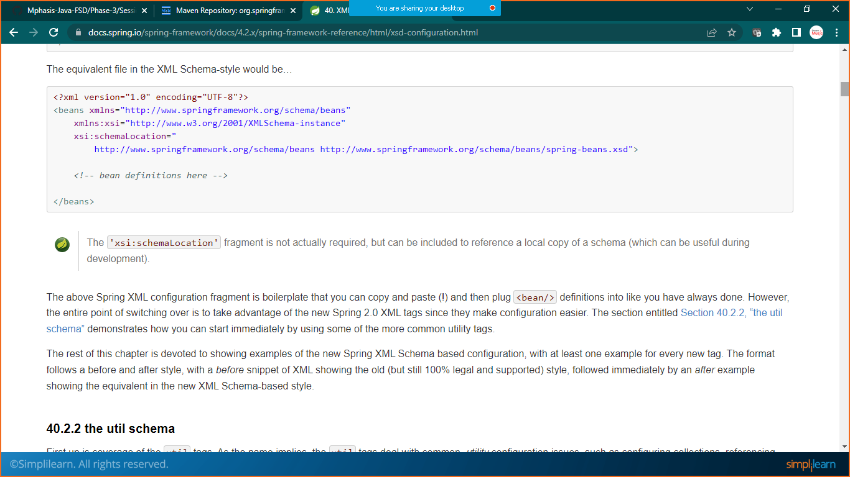copy xsd schema

<?xml version="1.0" encoding="UTF-8"?>

<beans xmlns="http://www.springframework.org/schema/beans"

xmlns:xsi="http://www.w3.org/2001/XMLSchema-instance"

xsi:schemaLocation="

http://www.springframework.org/schema/beans http://www.springframework.org/schema/beans/spring-beans.xsd">

*<!-- bean definitions here -->*

</beans>

Paste this code inside your **beans.xml** file

**Beans.xml**

<?xml version=*"1.0"* encoding=*"UTF-8"*?>

<beans xmlns=*"http://www.springframework.org/schema/beans"*

xmlns:xsi=*"http://www.w3.org/2001/XMLSchema-instance"*

xsi:schemaLocation=*"*

*http://www.springframework.org/schema/beans http://www.springframework.org/schema/beans/spring-beans.xsd"*>

<!-- copy this xsd file from: https://docs.spring.io/spring-framework/docs/4.2.x/spring-framework-reference/html/xsd-configuration.html -->

<!-- bean definitions here -->

<bean id=*"obj"* class=*"com.simplilearn.demo.HelloWorld"*></bean>

</beans>

Step:4 Code Execution

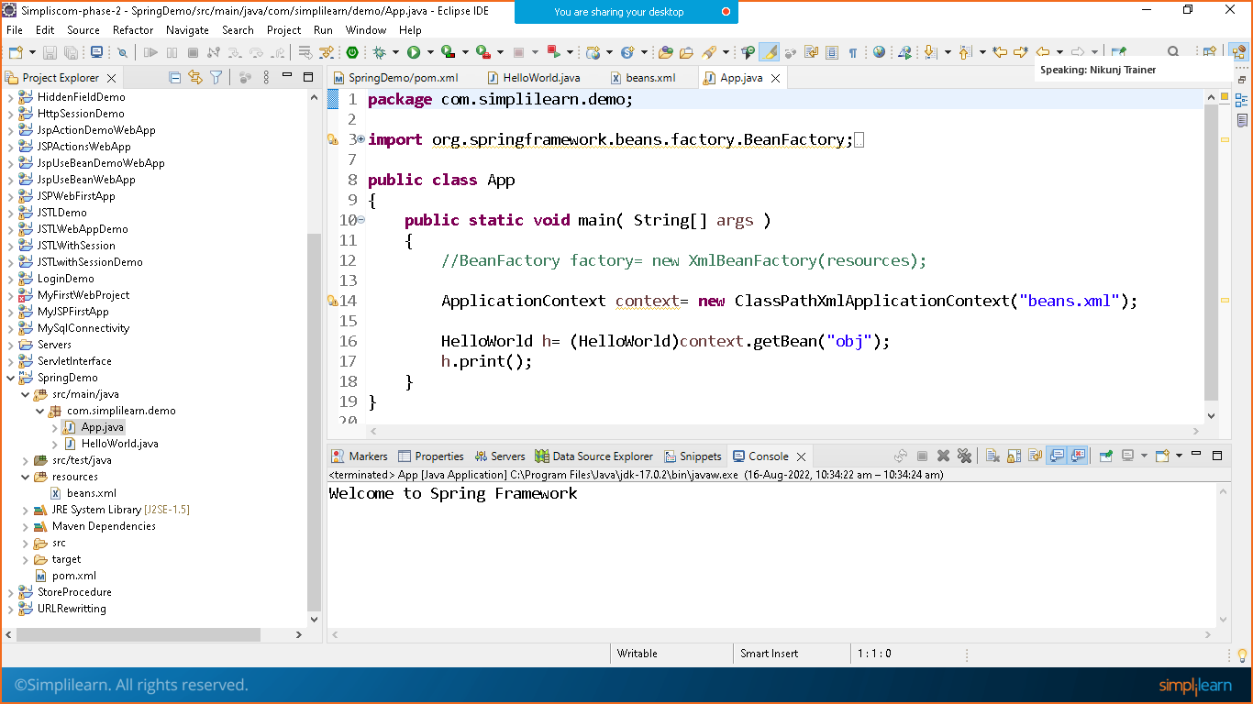

App.java

package com.simplilearn.demo;

import org.springframework.beans.factory.BeanFactory;

import org.springframework.beans.factory.xml.XmlBeanFactory;

import org.springframework.context.ApplicationContext;

import org.springframework.context.support.ClassPathXmlApplicationContext;

public class App

{

public static void main( String[] args )

{

//BeanFactory factory= new XmlBeanFactory(resources);

ApplicationContext context= new ClassPathXmlApplicationContext("beans.xml");

HelloWorld h= (HelloWorld)context.getBean("obj");

h.print();

}

}

**Right click on project and run as java application**

